Individual Pathways
Activity 10.2
Investigating energy doc-6094
- Read the following paragraph and highlight the key terms to help you answer the questions that follow.
All energy forms can be separated into one of two categories: potential energy (stored energy) or kinetic energy (energy that moving objects have). Therefore, electrical energy (which is due to moving charges), light energy (which is due to the movement of electromagnetic waves), sound energy (due to motion of compressional waves through a medium) and heat energy (due to the vibration and movement of particles) are actually all forms of kinetic energy. What we generally call kinetic energy could be described more precisely as macroscopic motion energy. On the other hand, gravitational, elastic, chemical and nuclear energy are all forms of potential energy.
- Summarise the information above into the following table. Provide an example of each of the energy types listed in the table.

Potential energy |  | Kinetic energy
Name of energy | Example | Name of energy | Example

- Describe the energy transformation illustrated below.

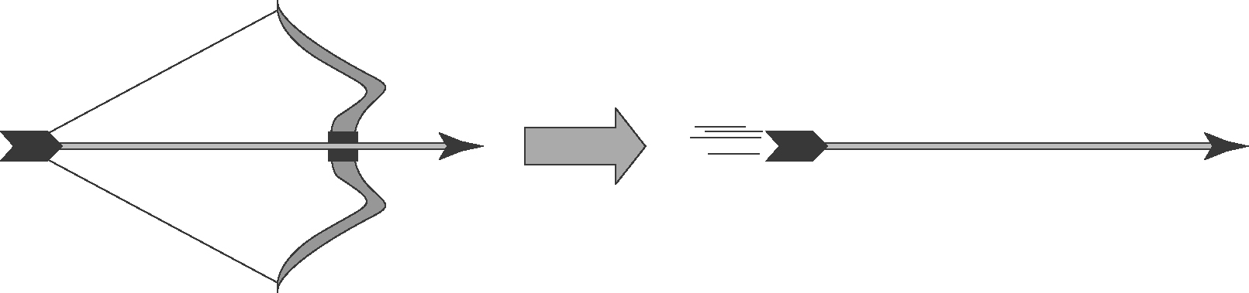
- Testing conduction
The heat conduction properties of a new material were tested. One end of a 100 cm long rod of the material was heated, and the temperature of the rod at the other end was recorded every minute. The data is tabulated below.
- Plot a line graph of the data and draw the line of best fit. (Start your graph at 20 °C.)
Time (min) | Temperature (°C)
0 | 20.0
1 | 25.0
2 | 29.8
3 | 35.2
4 | 40.0
5 | 44.7
6 | 50.3
7 | 54.9
8 | 59.9


- Use your graph to estimate the temperature of the rod at 3.6 minutes after the start.

- Identify the dependent and independent variables in this experiment.

- Convection
Consider the following illustration showing the movement of air near the ocean shore. Describe how the production of convection currents makes the climate near the coast milder than it is inland.
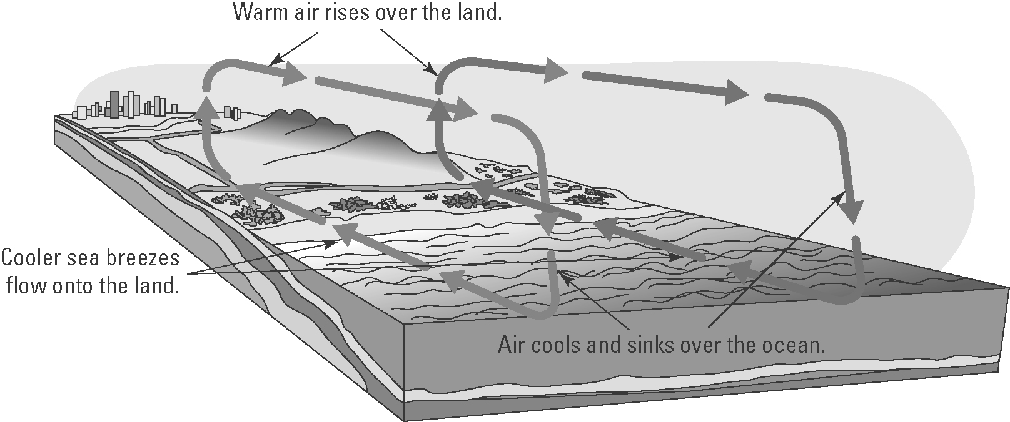

- The diagram below shows an incandescent light bulb.
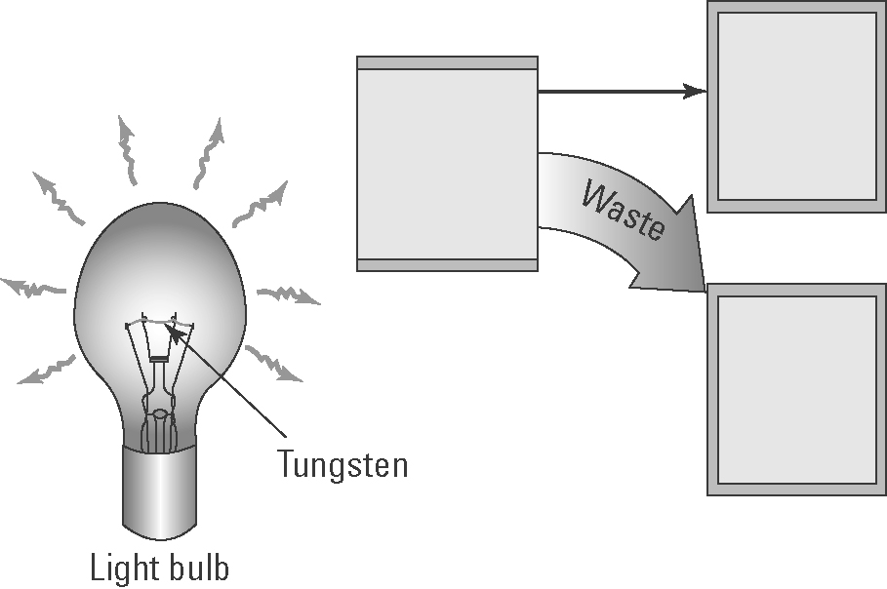
- Explain how an incandescent light bulb generates light.

- Insert the following words in the boxes in the diagram: heat energy, electrical energy, light energy.
- Explain why incandescent light bulbs are not energy efficient.

- Wavelength and frequency
The following diagram shows two vibrating tuning forks producing sound waves.
A | 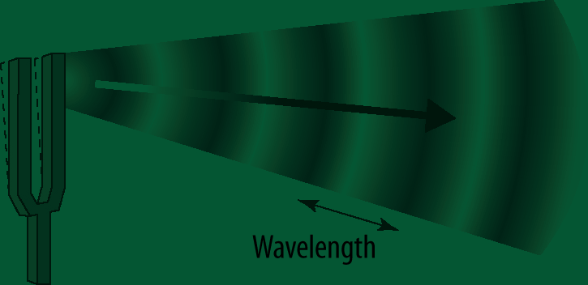 | (a) Identify the features of the wave labelled X and Y.  X:  Y:
B | 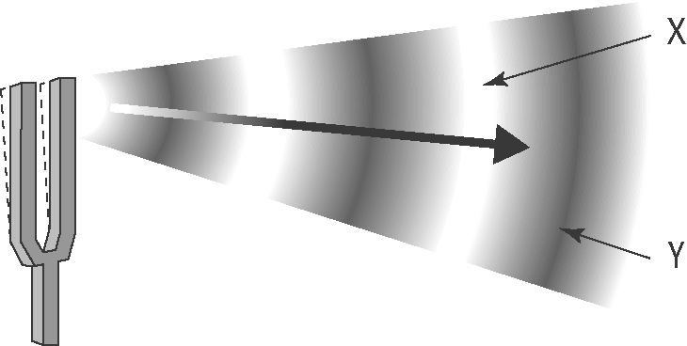 | (b) Which tuning fork produces sound waves with the lower pitch? Explain.
- Speed of sound in water
The following graph shows how the speed of sound (in m/s) in water varies with temperature (in °C).

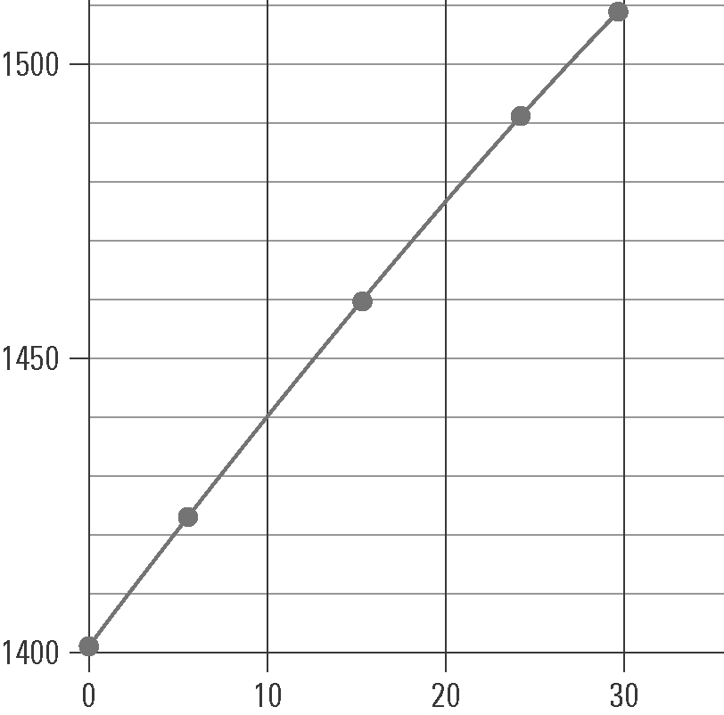

- The labels and units on each axis are not shown. Insert these labels and units.
- Give the graph a title.
- Use the graph to determine the speed of sound in water at:
(i) 0 °C
(ii) 10 °C
(iii) 20 °C
- In air, the speed of sound at 0 °C is 331 m/s.
(i) How many times faster does sound move in water than air at that temperature? (Hint: Divide one speed by the other.)

(ii) Explain why sound moves faster in water than in air.

